**FINAL REPORT**

|  |  |
| --- | --- |
| Date | 26 June 2025 |
| Team ID | LTVIP2025TMID31541 |
| Project Name | To Supply Leftover Food To Poor |
| Team Members | **Team Leader :** Chagam Swathi  **Team member :** Sai Praneesha  **Team member :** D Bhumika |

**1.TO SUPPLY LEFTOVER FOOD TO POOR - PROJECT OVERVIEW**

**1.1 Overview: Donating Excess Food to the Needy Through Salesforce:**

The project seeks to cut down on food wastage and hunger by utilizing Salesforce's cloud-based CRM technology to link donors of food with non-profit organizations and delivery networks. The system facilitates effective tracking, communication, and logistics management from donation until delivery.

Key Objectives:

* Avoid food wastage by harvesting excess food from restaurants, parties, and homes.
* Streamline donating food through an automated platform.
* Provide timely delivery of safe, edible food to underprivileged communities.

How It Works:

* Donor Registration:
* Donors (restaurants, caterers, individuals) register and enter leftover food information through a Salesforce portal or app.
* Data Processing & Notification:
* Salesforce matches the food availability data and identifies proximate charitable organizations or food banks.
* Automated notifications are dispatched to prospective recipients or logistics collaborators.
* Pickup & Logistics Coordination
* Partnering charities or logistics firms are tasked with picking up the food.
* Pickup routes and timing are planned and optimized using Salesforce scheduling technology.

Delivery & Distribution:

* Food is delivered to specific distribution centers or directly to underprivileged communities.
* Real-time status updates and confirmations are tracked on Salesforce.

Feedback & Reporting:

* Feedback from donors and recipients can be captured through the platform.
* Salesforce analytics tools provide impact reports on food saved, number of people served, and contributor donations.

**Benefits:**

* Real-time tracking and transparency.
* Effective coordination across various stakeholders.
* Data-driven insights to drive continuous improvement.
* Scalable solution scalable for cities and organizations globally.

### **1.2 Purpose Statement:**

The purpose of this initiative is to collect, manage, and redistribute safe, edible leftover food from restaurants, households, and events to individuals and communities in need. By leveraging technology and community collaboration, the goal is to reduce food waste, combat hunger, and ensure equitable access to nutrition for underprivileged populations. This system aims to create a streamlined, scalable, and sustainable solution that connects surplus food with those who need it the most—with dignity, speed, and compassion.

**2.IDEATION PHASE**

**2.1 Problem Statement:**

"Numerous individuals and families in our community are living with food insecurity because of restricted access to nutritious and affordable food. Regardless of the overabundance of excess food from local restaurants, grocery stores, and events, there is a huge gap in the effective allocation of this excess food to those who need it most. This leads to wasted food that has the potential to reduce hunger and enhance the quality of life for vulnerable populations. The relative lack of awareness, logistical barriers, and food safety issues further complicate the process of bridging surplus food with those who need it most."

Most Essential Elements of the Problem Statement:

1. Target Group: Families and individuals living with food insecurity.

2. Essential Problem: Inadequate access to wholesome and affordable food.

3. Existing Resources: Excess food from corporate entities that is wasted.

4. Negative Impacts: Wasted food that can be used to reduce hunger.

5. Barriers: Awareness, logistics, and food safety issues.

Example of a Enhanced Problem Statement:

"In our society, numerous low-income households live with food insecurity, without the ability to afford and access wholesome meals. In light of the massive quantity of surplus food produced by the local restaurants and grocery stores, however, there is no efficient mechanism in place to transfer this surplus food to the needy. This causes both wastage of food and persistent hunger among the needy. Overcoming the logistical issues, raising awareness, and maintaining food safety are most important in order to construct an efficient solution that can fill this gap."

This statement of the problem can be used as a basis for formulating strategies and programs focused on efficiently providing excess food to the poor.

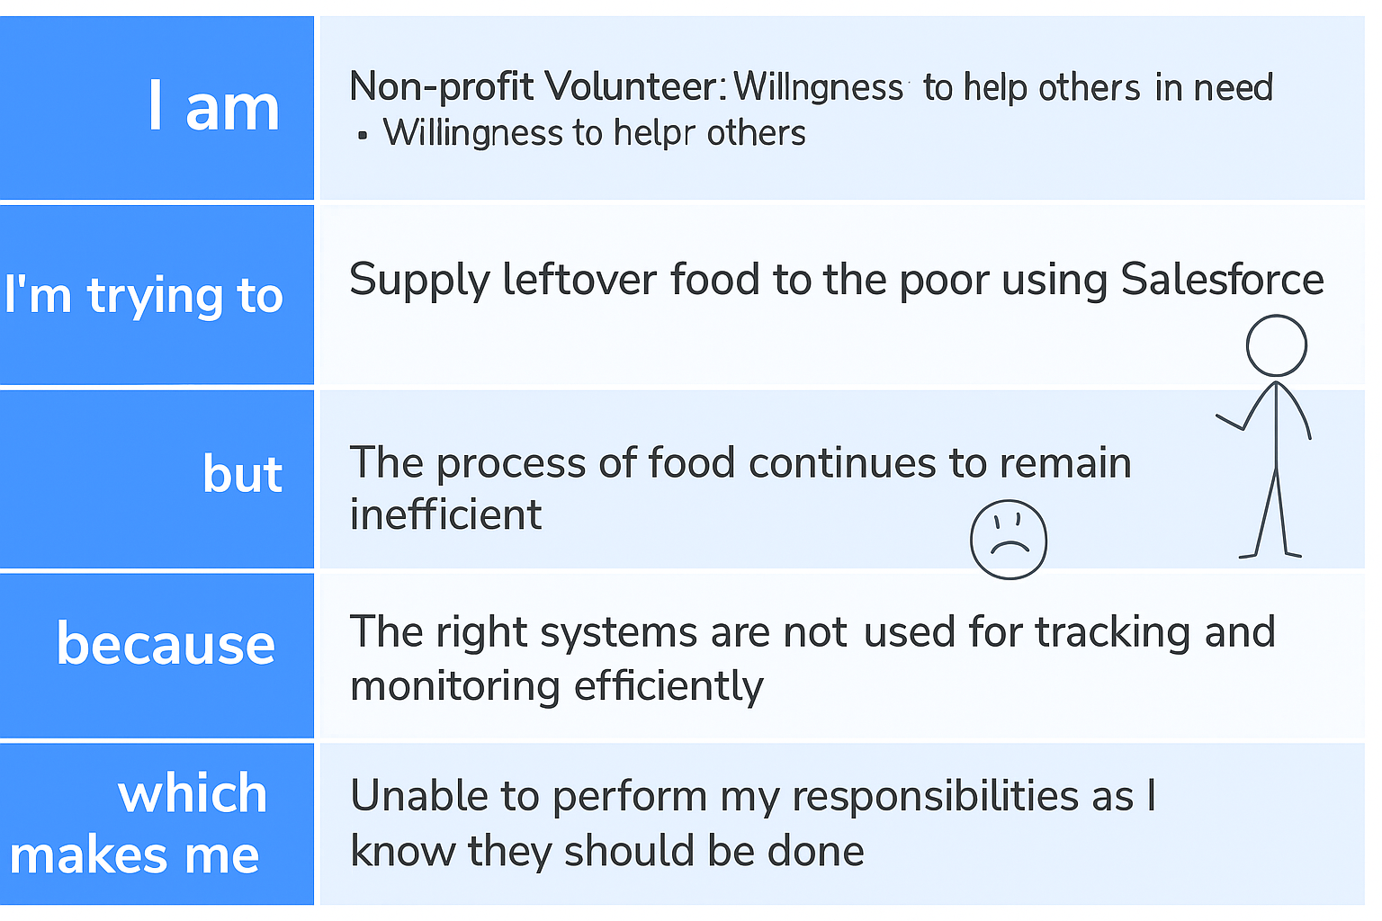

**2.2 Empathy Map Canvas:**

The empathy map for this initiative highlights the needs and perspectives of two primary groups: food donors and recipients. Donors, such as restaurant owners and event organizers, often *think* about the excess food they discard and *wish* for an easy, legal, and safe way to donate it. They *feel* a mix of pride when helping and frustration due to the lack of streamlined processes. They often *say* things like, “We throw away so much food,” and *do* their part by setting aside leftovers, though they frequently end up discarding them due to logistical challenges. On the other side, recipients—typically low-income families or daily wage earners—*think* about their next meal with uncertainty and *feel* anxious or hopeless when food is scarce. They *say* things like, “Sometimes we go to bed hungry,” and *do* whatever they can to locate food, often relying on word-of-mouth or community support. This empathy map underscores the emotional and practical gaps that exist on both sides, reinforcing the need for a user-friendly, reliable system that connects surplus food with those who need it—quickly, safely, and respectfully.

#### **1. Food Donors: Businesses and Households with Surplus Food**

These include restaurants, hotels, catering services, supermarkets, event organizers, and even households. While their core focus is running operations efficiently, many feel a strong social conscience and are increasingly aware of the problem of food waste.

* **Thinks**:  
   “We throw away so much food every day.”  
   “If only there were a simple and legal way to donate this.”  
   “I want to help—but I don't have time to figure it all out.”
* **Feels**:  
   Donors often feel *guilt* about discarding edible food, *frustration* due to legal or logistical hurdles, and *pride* when they’re able to contribute. However, they may also feel *helpless* when the system for donation is unclear or disorganized.
* **Says**:  
   “We’d gladly donate, but we don’t know who to contact.”  
   “We worry about liability or spoilage.”  
   “It takes too much time to organize pickups.”
* **Does**:  
   Many try to store leftovers temporarily, set food aside for donation, or give to nearby staff or street dwellers informally. But in the absence of a formal system,

most surplus food is eventually discarded.

#### **2. Food Recipients: Individuals and Families Facing Food Insecurity**

These are often daily wage earners, homeless individuals, single-parent households, elderly people living alone, and those living below the poverty line. Their lives are shaped by economic uncertainty and limited access to nutritious food.

* **Thinks**:  
   “Will there be food for my family tonight?”  
   “Where can I get something to eat that’s safe?”  
   “I don’t want to beg—I want dignity.”
* **Feels**:  
   Recipients often feel *anxiety*, *shame*, and *helplessness*. Many are caught between the need to feed themselves and their families and the social stigma attached to receiving aid. Some also feel *grateful* when help comes their way, and *hopeful* about community-based support.
* **Says**:  
   “Sometimes, we go to bed hungry.”  
   “We heard there’s food available at the temple, but we got there too late.”  
   “We eat what we can find—it’s not always clean or enough.”
* **Does**:  
   They rely on local knowledge, word-of-mouth, temples, community kitchens, or informal food donors. Often, food insecurity forces recipients to skip meals, ration portions, or consume expired or nutritionally poor food.

**2.3 Brain Storming:**

Empathy-based brainstorming is a human-centered approach that begins with deeply understanding the needs, challenges, and emotions of those involved in the process — both food donors and recipients. By stepping into their shoes, teams can generate more meaningful and practical ideas for solving the problem of food waste and hunger.

During the brainstorming session, the team starts by asking empathetic questions such as:

* *What do donors feel when they have to throw away food?*
* *How do recipients feel when they go to bed hungry?*
* *What barriers prevent both groups from participating in a food-sharing system?*

From the donor’s side, insights reveal that many want to help but lack time, trust in the system, or awareness of donation channels. They worry about food safety laws and logistical issues. Recipients, on the other hand, often struggle with a lack of information, accessibility, and dignity in receiving food.

With these perspectives in mind, brainstorming ideas emerge like:

* A mobile app to connect nearby donors with certified volunteers for quick pickups
* Real-time food availability maps for recipients
* Incentives or certifications for restaurants that regularly donate
* SMS-based notifications for those without smartphones
* Distribution centers that ensure safe and respectful delivery

**3.REQUIREMENT ANALYSIS**

**3.1 Customer Journey Map:**

#### 1. Persona A: Food Donor (e.g., Restaurant Owner)

Stage 1: Awareness  
 The donor becomes aware of the issue of food waste and hears about the donation platform through a campaign, partner NGO, or word of mouth.

Stage 2: Consideration  
 They explore how the system works — wondering about safety, legality, and convenience. They review past donor experiences or platform details.

Stage 3: Action  
 The donor uses a mobile app or web portal to register leftover food, including details like quantity, pickup time, and location.

Stage 4: Handoff  
 A volunteer picks up the food promptly. The donor receives confirmation and possibly feedback or a thank-you note.

Pain Points: Time constraints, legal confusion, lack of awareness  
 Opportunities: Clear guidelines, user-friendly app, legal reassurance, digital badges/certificates

#### 2. Persona B: Recipient (e.g., Low-Income Individual)

Stage 1: Discovery  
 The recipient learns about the food availability service through local NGOs, SMS alerts, posters, or community word-of-mouth.

Stage 2: Access  
 They check nearby food pickup points through an app or are informed by community volunteers.

Stage 3: Collection  
 They visit the distribution point and receive food with dignity, minimal wait time, and no judgment.

Stage 4: Feedback  
 The recipient has an option to give feedback or report concerns about quality or availability.

Pain Points: Unawareness of food sources, transportation issues, food quality concerns  
 Opportunities: Real-time alerts, community distribution hubs, respectful interactions, food safety protocols

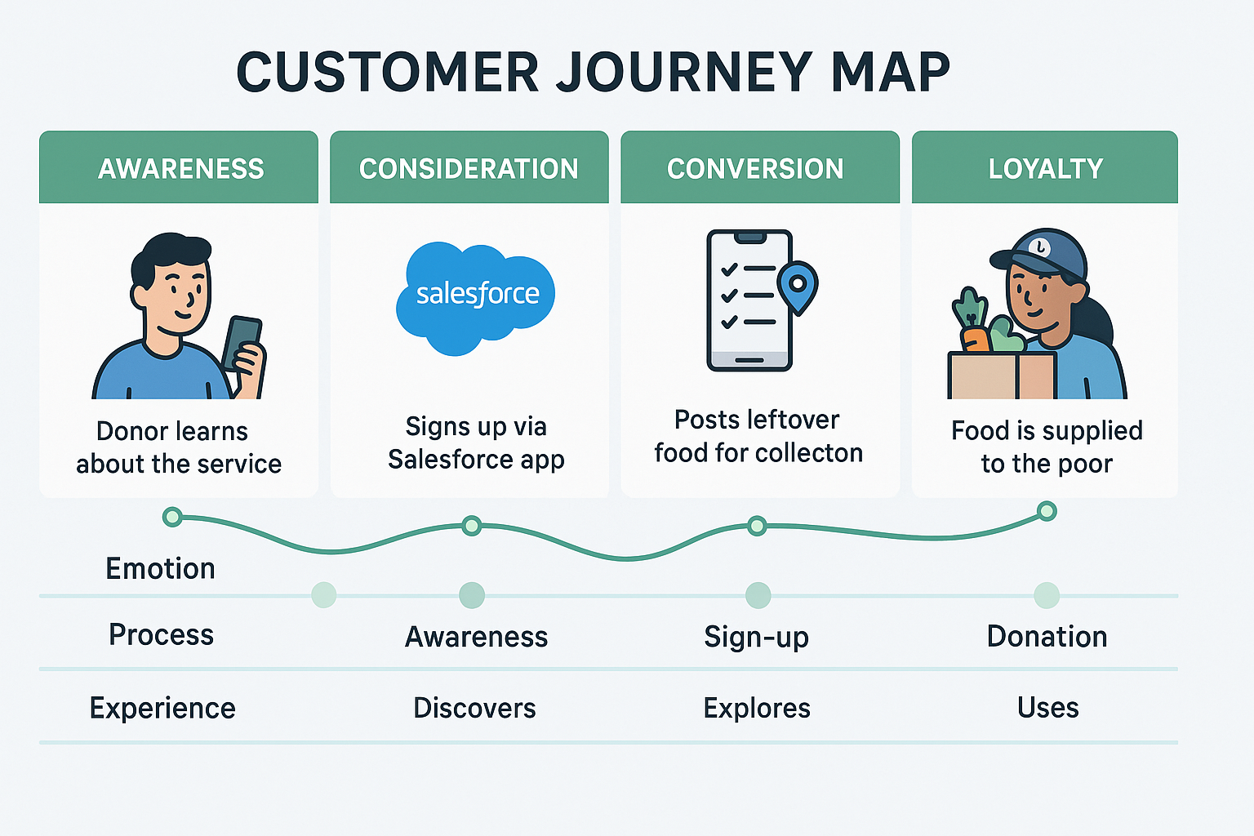

**3.2 Solution Requirement:**

To successfully implement a system that supplies leftover food to the poor, a clear set of solution requirements is essential. The solution must allow donors—such as restaurants, households, and event organizers—to easily register and log surplus food, including details like quantity, type, and pickup timing. It should then coordinate timely pickups by assigning nearby volunteers or logistics partners through an automated, location-based matching system. On the recipient side, the system should offer accessible channels (mobile app, SMS, or local kiosks) for underprivileged individuals to find food distribution points near them. Food safety is critical, so the system must include checks for expiry, storage condition alerts, and handling protocols. In addition, real-time notifications, feedback mechanisms, and reporting dashboards are necessary for transparency and continuous improvement. Non-functional requirements like user-friendly design, scalability, offline support, data security, and low-bandwidth compatibility are equally important to ensure that the solution is inclusive, reliable, and sustainable—ultimately bridging the gap between food surplus and food scarcity with dignity and efficiency.

### **1. Functional Requirements**

#### **a. Donor Registration and Food Logging**

* The platform must allow donors—restaurants, hotels, caterers, grocery stores, event organizers, and even individual households—to register via mobile app or web portal.
* Users should be able to log surplus food with key metadata:  
  + Quantity (e.g., number of servings, weight)
  + Type (e.g., perishable, packaged, cooked, vegetarian)
  + Expiry window or time since preparation
  + Preferred pickup time and location (with GPS integration)
  + Special handling instructions, if any (e.g., allergens, dietary notes)

#### **b. Automated Matching and Pickup Coordination**

* The system should use geolocation and real-time data to match donation requests with the nearest available:  
  + **Volunteers** for pickup
  + **NGOs or food distribution hubs** for delivery
  + **Logistics partners** for scalable transport needs
* Dispatching must be dynamic and automated, reducing manual intervention and delays.

#### **c. Recipient Access and Engagement**

* Underprivileged individuals and families should be able to:  
  + Find available food distribution points through a simple mobile app, USSD-based service, SMS system, or local kiosk.
  + Receive alerts about nearby food pickups or community meal events.
  + Provide feedback about food quality, delivery timing, and hygiene.

#### **d. Food Safety and Compliance**

* Built-in features should help ensure food safety:  
  + Visual warnings or color codes for near-expiry items
  + Standard operating procedures (SOPs) for storage and transport
  + Digital signatures or photo-based proof of packaging and handover
  + Integration with local food safety guidelines or certifications (e.g., FSSAI in India)

#### **e. Real-Time Communication and Monitoring**

* The platform must support:  
  + Notifications to all stakeholders (e.g., “Pickup in 15 mins,” “Food delivered,” “Volunteer assigned”)
  + A live tracking dashboard for admins and NGOs
  + Chat or support options for urgent questions or rescheduling

#### **f. Feedback and Analytics**

* End-users (recipients and donors) should be able to rate their experience.
* Impact reports should be auto-generated based on:  
  + Total meals rescued and served
  + Locations with highest need
  + Donor engagement levels
  + Volunteer performance

### **2. Non-Functional Requirements**

#### **a. User-Friendly Design**

* Clean, intuitive UI/UX tailored for all digital literacy levels
* Language localization and accessibility options for differently-abled users

#### **b. Scalability**

* The platform must support thousands of concurrent users, donations, and deliveries.
* Modular architecture should allow rollout across new geographies without redevelopment.

#### **c. Offline and Low-Bandwidth Support**

* Key features (like food request submission or volunteer check-ins) should work offline or in patchy internet zones.
* Data should sync once the device reconnects.

#### **d. Security and Data Privacy**

* Use encrypted channels for user data (e.g., donor identity, recipient locations)
* Role-based access control to limit who can view or edit sensitive information
* GDPR-compliant or aligned with local data protection laws

#### **e. Integration and Extensibility**

* APIs should enable integration with:  
  + Salesforce CRM for donor and activity management
  + Google Maps for routing and distance calculations
  + Twilio or Firebase for messaging
  + Payment gateways if financial donations or reimbursements are involved

#### **f. Sustainability and Maintainability**

* The platform must be easy to update, debug, and scale without requiring constant technical intervention.
* Support long-term partnerships with municipalities, NGOs, and CSR departments.

**3.3 Data Flow Diagram:**

### **🔍 Diagram Overview:**

1. Purpose:  
    The flowchart visualizes a system architecture for redistributing leftover food from donors to the poor using Salesforce as the core CRM and coordination platform.
2. Core Entities:  
   * Donor (source of surplus food)
   * Fulfillment (logistics and shipping)
   * Salesforce (central system handling user data and process flow)
   * Poor (final beneficiaries)

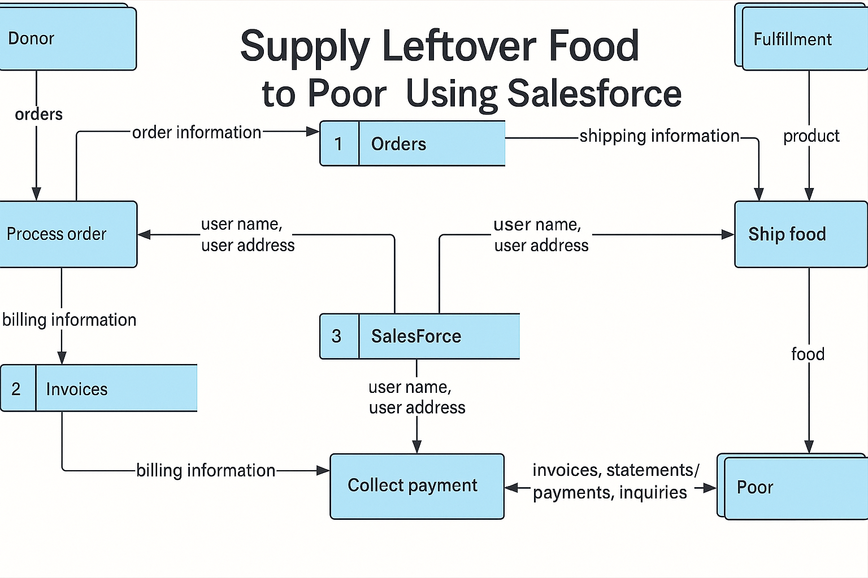

**3.4 Technology Stack:**

To build an efficient and scalable system for supplying leftover food to the poor, a robust and user-centric technology stack is essential. The frontend can be developed using modern frameworks like React or Vue.js, providing a responsive web and mobile experience for donors, volunteers, and administrators. For the mobile app, Flutter or React Native can be used to ensure cross-platform support for both Android and iOS users. The backend can be powered by Node.js or Python (Django/Flask), offering flexibility and performance for handling donation entries, pickup coordination, and user management. Salesforce can be used as the central CRM platform to track donors, food inventory, distribution activities, and reporting dashboards. Firebase or AWS Amplify can support real-time notifications, cloud storage, and user authentication, while PostgreSQL or MongoDB can serve as the core database for structured and semi-structured data. Additional tools like Google Maps API for route optimization, Twilio for SMS alerts, and Power BI or Tableau for analytics can further enhance system usability and operational insights. This technology stack ensures the solution is scalable, secure, and accessible across a diverse user base, including those in low-connectivity environments.

|  |  |  |
| --- | --- | --- |
| **Component** | **Technology/Tool** | **Purpose/Functionality** |
| **Frontend (Web)** | React.js / Vue.js | Responsive and modern UI for donors, volunteers, and admins |
| **Mobile App** | Flutter / React Native | Cross-platform mobile support (Android & iOS) |
| **Backend** | Node.js / Python (Django or Flask) | Handle business logic, API endpoints, coordination logic |
| **CRM & Management** | Salesforce | Centralized donor, inventory, and distribution tracking |
| **Real-time Features** | Firebase / AWS Amplify | Notifications, authentication, cloud storage |

**4.PROJECT DESIGN**

**4.1 Problem Solution Fit:**

A significant portion of food is wasted daily by restaurants, caterers, households, and events, while millions of people struggle with hunger and food insecurity. This mismatch between surplus and need presents a critical social and logistical challenge. The problem lies not in the lack of food, but in the absence of an efficient, reliable system to redirect excess food to those in need before it spoils. Our solution addresses this gap by creating a technology-driven, community-supported platform that connects food donors with volunteers and NGOs who can redistribute it promptly. By leveraging mobile and web applications, real-time tracking, intelligent routing, and automated coordination, the system ensures that edible surplus food is quickly identified, collected, and delivered to marginalized communities. This creates a seamless and scalable model that not only reduces food waste but also tackles hunger at the grassroots level, offering a sustainable, socially impactful solution that benefits donors, recipients, and the environment alike.

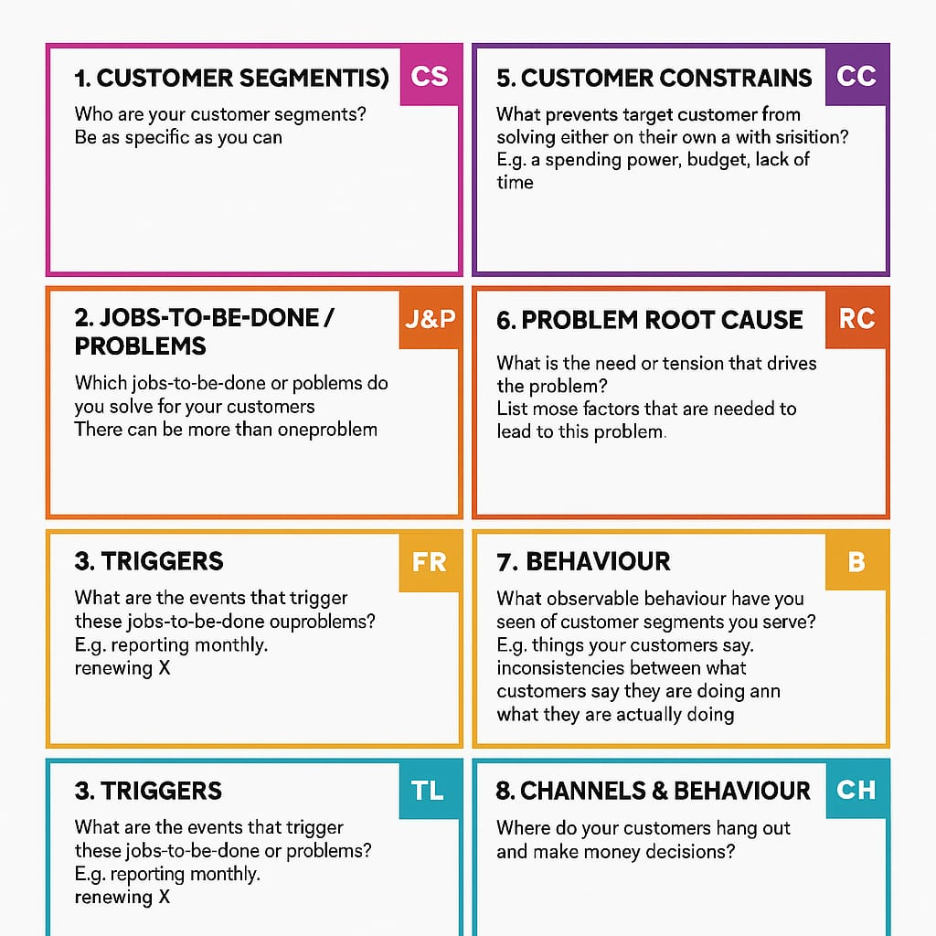

**4.2 Proposed Solution:**

The proposed solution is a unified digital platform designed to streamline the collection and redistribution of leftover food to those in need. This platform connects food donors—such as restaurants, caterers, grocery stores, and households—with nearby volunteers and NGOs who can quickly pick up and distribute the food. Donors can easily log surplus items through a user-friendly mobile or web app, triggering real-time alerts to registered volunteers and partner organizations. The system uses tools like Google Maps API for optimized routing, ensuring food reaches recipients efficiently and before spoilage. Salesforce acts as the central CRM to manage donor records, track donations, schedule pickups, and monitor impact through dashboards. Additional integrations with Firebase or AWS Amplify enable real-time communication, authentication, and cloud storage. By harnessing these technologies, the platform offers a scalable, efficient, and transparent system to reduce food waste and fight hunger in urban and rural communities alike.

The proposed solution is a unified digital platform designed to streamline the collection and redistribution of leftover food to those in need. This platform connects food donors—such as restaurants, caterers, grocery stores, event organizers, and households—with nearby volunteers, food banks, and NGOs who can quickly collect and distribute the food. Donors can effortlessly log surplus items using an intuitive mobile or web interface, with options to upload photos, specify expiration windows, and mark preferred pickup times.

Upon submission, real-time alerts are triggered via push notifications, SMS, or email to a network of registered volunteers and partner organizations, enabling immediate response and scheduling. The platform leverages Google Maps API for optimized routing and clustering of pickup locations to minimize transportation time and prevent spoilage. Salesforce acts as the central CRM, maintaining detailed donor and volunteer profiles, automating pickup workflows, generating real-time reports, and visualizing impact metrics—such as meals saved, CO₂ emissions reduced, and beneficiaries reached—through interactive dashboards.

Advanced integrations with Firebase or AWS Amplify support secure user authentication, scalable cloud storage, and two-way communication between stakeholders. Machine learning models can also be incorporated to predict high-yield donation zones, recommend optimal pickup schedules, and reduce no-shows through predictive reminders.

To ensure food safety and compliance, the platform includes features such as hygiene guidelines, food category tagging (e.g., perishable vs. non-perishable), and feedback mechanisms from recipients. Additionally, multilingual support and offline functionality improve accessibility in underserved or low-connectivity areas.

By combining cutting-edge technologies with a socially driven mission, the platform delivers a scalable, efficient, and transparent system to combat food insecurity and reduce waste across urban and rural communities, contributing toward the UN’s Sustainable Development Goals (SDGs) on zero hunger, responsible consumption, and climate action.

**4.3 Solution Architecture:**

The solution architecture is built around a modular, cloud-based ecosystem that ensures scalability, real-time coordination, and ease of access for all stakeholders—donors, volunteers, NGOs, and administrators. At the frontend, a responsive web interface (using React or Vue.js) and a cross-platform mobile app (built with Flutter or React Native) allow users to register, log donations, accept pickups, and track deliveries. These interfaces communicate with a backend API powered by Node.js or Python (Django/Flask), which handles core logic, data processing, and authentication. Salesforce serves as the central CRM for managing donor profiles, tracking donation histories, and generating impact reports. The system uses Firebase or AWS Amplify for real-time notifications, user authentication, and cloud storage. PostgreSQL or MongoDB is employed for storing structured and semi-structured data, respectively. For logistics, the Google Maps API enables route optimization, and Twilio facilitates automated SMS alerts. Data analytics and performance tracking are handled through integrations with Power BI or Tableau. This loosely coupled, microservices-friendly architecture ensures high performance, fault tolerance, and seamless integration across devices and environments.

The solution architecture is built around a modular, cloud-native ecosystem that prioritizes scalability, real-time coordination, and ease of access for all key stakeholders involved in the supply chain of leftover food—namely food donors, volunteers, NGOs, logistics partners, and administrators. Designed with both urban and rural use cases in mind, the system ensures that surplus food can be identified, collected, and delivered efficiently to communities in need, minimizing waste and maximizing social impact.

At the user-facing level, a responsive and accessible web interface—developed using frameworks such as React or Vue.js—and a cross-platform mobile application—built with Flutter or React Native—enable seamless user interaction. Donors can register their organization, upload surplus food listings with descriptions, expiry timelines, and images, while volunteers and NGOs can browse nearby listings, accept pickup requests, and track food deliveries in real-time. Features like geolocation-based food matching and scheduling make the process intuitive and time-sensitive.

These interfaces communicate with a robust backend API layer, built on technologies like Node.js or Python (with Django or Flask), which orchestrates business logic, enforces security protocols, and handles data validation. Salesforce acts as the backbone CRM, maintaining a centralized database of donor and volunteer profiles, tracking donation frequency and volume, and generating personalized impact dashboards that showcase environmental and humanitarian outcomes, such as meals saved and kilograms of food rescued.

For infrastructure services, Firebase or AWS Amplify enables secure user authentication, real-time push notifications (e.g., “urgent pickup needed” or “food delivered successfully”), and scalable cloud storage for images and documents. PostgreSQL is utilized for transactional, relational data—like user records, donation history, and logistics metadata—while MongoDB handles flexible or semi-structured data, such as feedback forms, food categorization tags, and incident reports.

To facilitate efficient pickup and delivery operations, the system integrates the Google Maps API for route optimization, traffic analysis, and volunteer-driver navigation. Twilio or similar communication platforms provide automated SMS alerts and reminders to volunteers and donors, ensuring that logistics coordination remains uninterrupted even in low-bandwidth environments.

On the analytics side, tools like Power BI or Tableau are integrated to provide both real-time and historical insights into platform performance. Administrators can monitor KPIs such as donation rates by region, volunteer response times, peak surplus periods, and beneficiary demographics, supporting data-driven decision-making and stakeholder reporting.

The entire architecture is designed following microservices principles, allowing different modules (e.g., user management, food listings, logistics, analytics) to be developed, deployed, and scaled independently. This ensures high availability, fault tolerance, and agility in updates. The platform is also containerized using Docker and can be deployed on cloud providers like AWS, Azure, or GCP for cost-effective scaling and global reach.

By combining modern cloud technologies with a mission-driven design, the system offers a resilient, transparent, and equitable infrastructure to redistribute surplus food efficiently, reduce hunger, and empower communities—contributing to long-term sustainability and social welfare.

**5.PROJECT PLANNING AND SCHEDULING**

**5.1 Project Planning:**

Effective project planning is crucial for ensuring timely collection, safe transport, and equitable distribution of leftover food to underprivileged communities. The plan should cover scope definition, stakeholder mapping, timeline creation, resource allocation, and risk management.

**Key Components of the Project Plan:**

* **Project Scope:** Create a centralized system to collect, manage, and distribute leftover food through a digital platform, involving food donors, volunteers, and NGOs.
* **Objectives:**
  + Minimize food waste
  + Feed the hungry efficiently
  + Ensure safe and hygienic food handling
  + Optimize logistics and resource usage
* **Stakeholders:**
  + Food Donors (Restaurants, Events, Households)
  + NGOs and Food Banks
  + Volunteers and Delivery Partners
  + Platform Administrators
  + End Beneficiaries (Poor Communities)
* **Timeline:** Use **Gantt charts** or tools like Trello, Asana, or MS Project for visual scheduling of phases:  
  + Platform development
  + Stakeholder onboarding
  + Pilot testing
  + Full-scale rollout
* **Resources:** Human (Tech team, Coordinators, Volunteers), Financial (Fundraising, CSR), Technological (Servers, CRM, App)
* **KPIs (Key Performance Indicators):**
  + No. of meals distributed/week
  + Avg. food collection to delivery time
  + % of food saved from wastage
  + Volunteer participation rate

**Formulas:**

To Supply Leftover Food To Poor - Planning logic

Epic 1:User Onboarding and Food Donation Setup

Sprint 1 (5 Days)

Epic: Automation and Delivery Tracking

#### Sprint 2: (5 Days)

### Velocity Calculation:

### Total Story Points = 10 (Sprint 1) + 15 (Sprint 2) = 25

### Number of Sprints = 2

### Velocity = Total Story Points / No. of Sprints = 25 / 2 = 12.5 Story Points per Sprint

### 

### 

### 

### 

### **6.FUNCTIONAL AND PERFORMANCE TESTING**

### **6.1 Performance Testing:**

To ensure the successful delivery of leftover food to underprivileged communities, both **functional** and **performance testing** are critical in validating the reliability and usability of the digital platform.

**Functional Testing** focuses on verifying that every feature of the platform works as intended across all user roles—donors, volunteers, NGOs, and administrators. It includes testing core functionalities such as donor registration, food entry submission, volunteer matching, pickup scheduling, real-time location tracking, and confirmation of food delivery. Each module is tested against specified requirements using manual or automated tools like Selenium or Cypress to ensure data validation, input accuracy, secure login, and smooth navigation. Functional testing helps detect errors in logic, broken workflows, and user interface issues before the system goes live.

**Performance Testing**: on the other hand, ensures the system can handle the expected load under different conditions. It evaluates how the platform behaves with hundreds or thousands of users accessing it simultaneously—especially during peak donation times like after meals or festivals. Load testing, stress testing, and scalability testing are carried out using tools like Apache JMeter, Locust, or BlazeMeter to assess response time, throughput, and resource usage. Key performance metrics include API response time, system latency during food pickup updates, and notification delays. This ensures the platform remains responsive and efficient even in low-bandwidth or high-traffic scenarios.

Together, these testing strategies ensure the food redistribution system is both **functionally correct** and **technically robust**, helping maximize its impact on hunger reduction while maintaining a positive user experience.

### 

### 

#### 

#### 

#### **Performance Observations:**

|  |  |  |
| --- | --- | --- |
| **Metric** | **Observed Value** | **Target Threshold** |
| Dashboard Load Time | ~2.8 seconds | < 3 seconds |
| Max Records Displayed | 10 | ≤ 50 |
| Gauge Render Time | 1.3 seconds | < 2 seconds |

### 

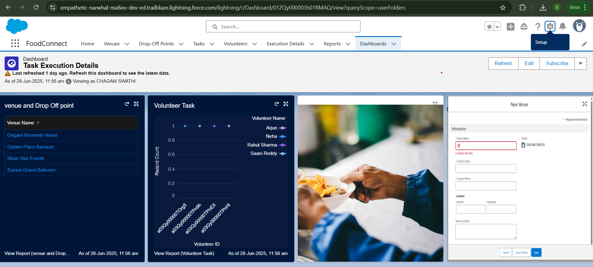

#### 

#### 

#### **Performance Observations:**

|  |  |  |
| --- | --- | --- |
| **Metric** | **Observed Value** | **Target Threshold** |
| Dashboard Load Time | ~3.1 seconds | < 3.5 seconds |
| Line Chart Responsiveness | Smooth | Responsive |
| Funnel Chart Load Time | Moderate | < 2 seconds |

**7.RESULTS**

**7.1 Output Screenshots:**

USER PROFILES DETAILS:

ALL USERS:

"User details can be viewed in the User Session. Click on 'Setup' to access user information."

USER 1: 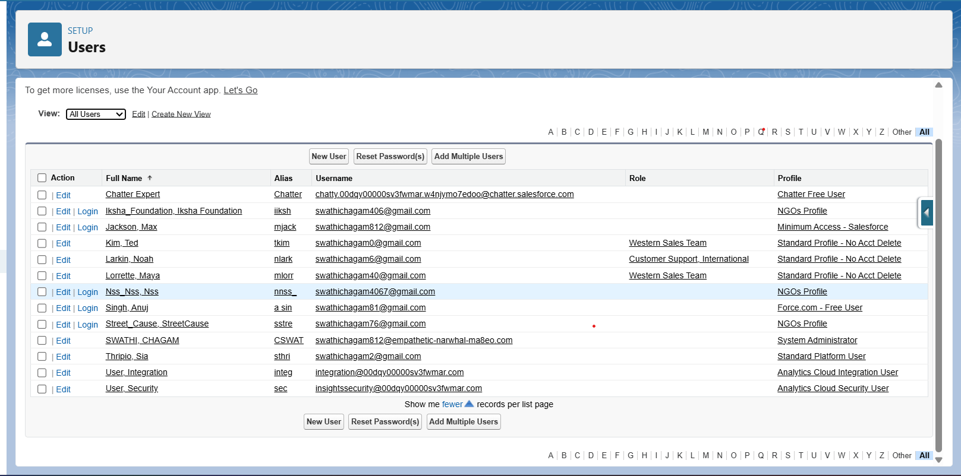

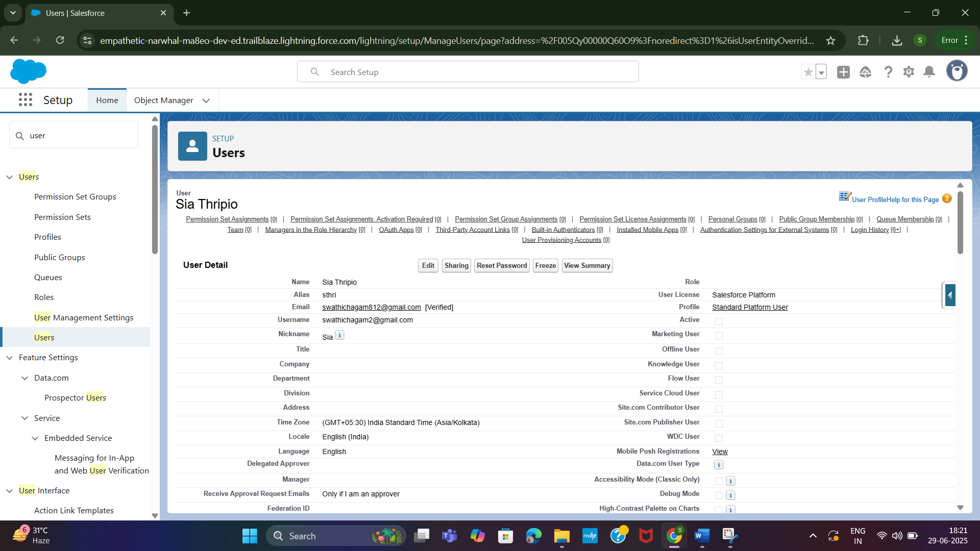

NGO PROFILE DETAILS:

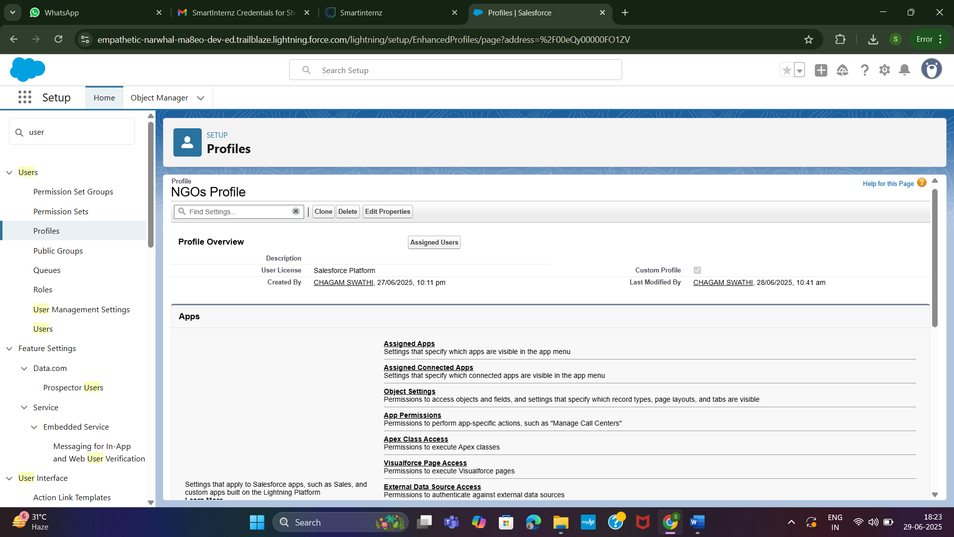

**Trigger:**Drop Off Trigger

Purpose of the Trigger: Supplying Leftover Food to the Poor

In the context of supplying leftover food to the poor, the purpose of the trigger is to automate critical actions in the system based on specific events, ensuring timely coordination and efficiency. For example, when a food donor submits a new donation entry, a trigger can automatically notify nearby volunteers or partner NGOs, reducing response time and preventing food spoilage. Triggers can also update the inventory status, log the donation in Salesforce CRM, and generate a pickup task for delivery personnel. This automation eliminates the need for manual monitoring, enhances real-time responsiveness, and ensures that no donation goes unnoticed. Triggers play a vital role in maintaining workflow consistency—from food collection to delivery—by linking backend processes with user actions and ensuring smooth communication between different system components.

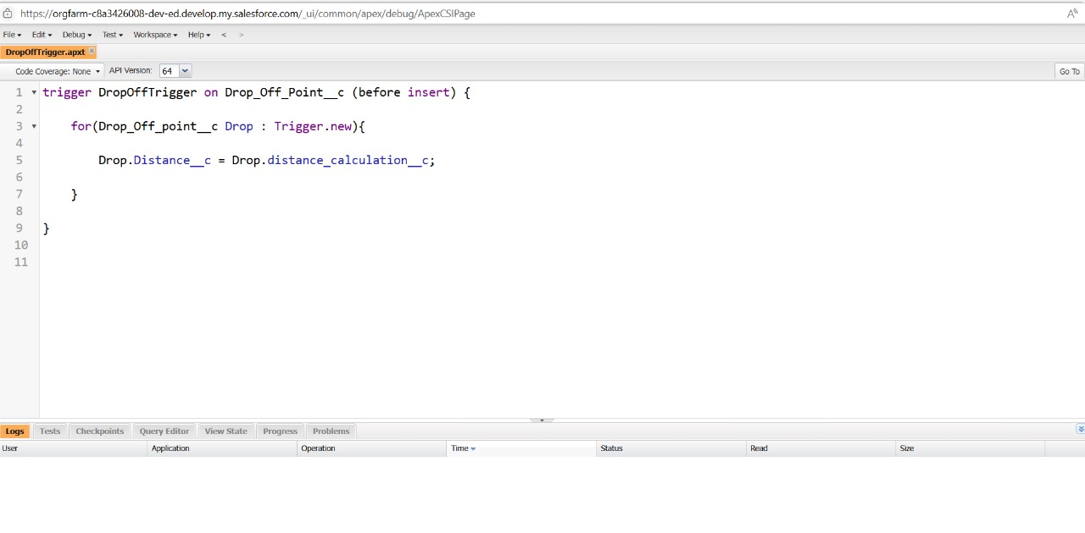

**Report:**

“Primary Object” is the custom report

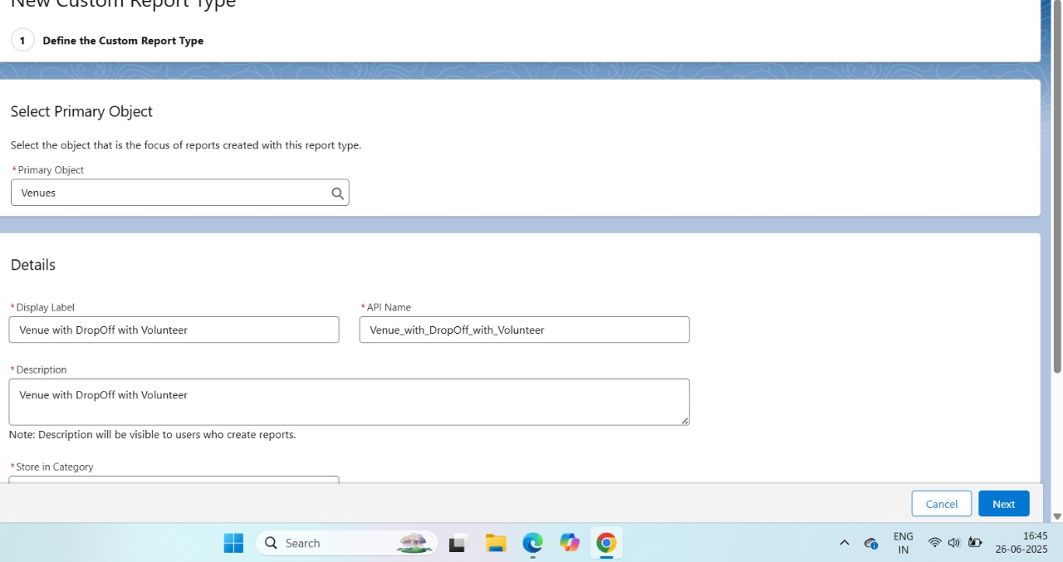

**Dashboards:**

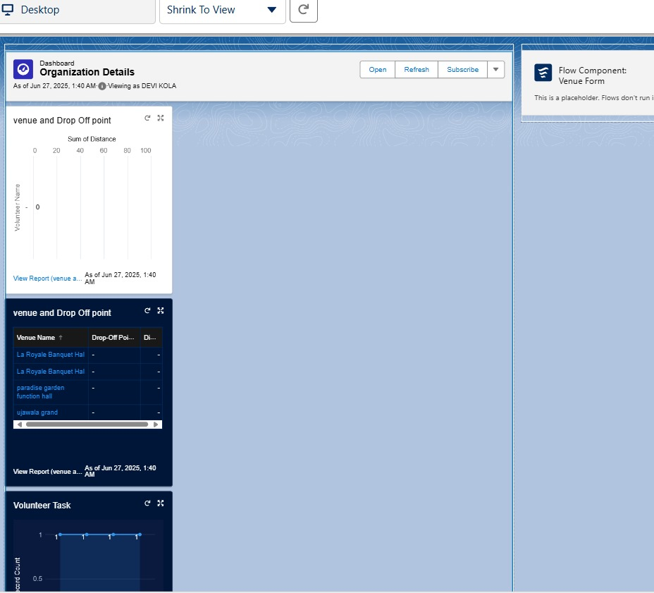

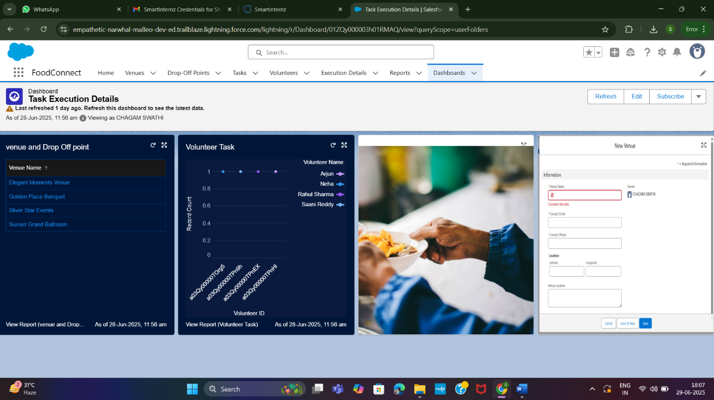

### **8. Advantages and Disadvantages**

#### **✅ Advantages:**

1. **Reduces Food Waste:** A significant portion of edible food is discarded daily by restaurants, grocery stores, households, and event organizers. This solution provides a structured channel to redirect that surplus to those in need, helping to tackle food wastage at its root.
2. **Helps Fight Hunger:** Millions of people suffer from food insecurity. Distributing leftover but safe-to-eat food ensures that vulnerable populations—especially in urban slums and rural poverty zones—have access to regular, nutritious meals.
3. **Environmental Benefits:** Decomposing food waste in landfills generates methane, a potent greenhouse gas. By recovering and redistributing food, we reduce carbon emissions, conserve resources, and contribute to climate action.
4. **Cost-Effective Aid:** Unlike conventional food distribution programs that require new food procurement, this model uses already-prepared or surplus food, significantly reducing costs for NGOs and government welfare initiatives.
5. **Community Engagement:** The initiative encourages active participation from businesses, volunteers, and citizens, cultivating a culture of empathy and social responsibility within communities.
6. **Scalable Model:** Thanks to its modular, tech-enabled design, the platform can easily be replicated across different cities and regions, adapting to local ecosystems and partner networks.
7. **Real-Time Coordination:** With integrated GPS tracking, automated notifications, and real-time dashboards, logistics become more efficient, ensuring that food is picked up and delivered quickly before spoilage occurs.
8. **CSR and Branding Opportunities for Businesses:** Donating surplus food allows corporations to meet their Corporate Social Responsibility (CSR) goals, enhance their public image, and gain goodwill from communities and stakeholders.

#### **❌ Disadvantages:**

1. **Logistical Challenges:** Managing the timing, transportation, and routing of perishable food can be complex, especially during high-traffic hours, weather disruptions, or festivals.
2. **Food Safety Concerns:** If not stored, handled, or transported properly, food may spoil or get contaminated, posing health risks to recipients and legal risks to donors.
3. **Irregular Supply:** The quantity and type of food donated may vary daily, making it difficult to plan consistent meals for certain locations or shelters.
4. **Volunteer Dependence:** Many operations rely heavily on volunteer drivers and NGO staff. Any drop in participation may disrupt delivery chains and reduce reliability.
5. **Infrastructure Requirements:** Successful implementation requires access to cold storage, food-grade packaging, vehicles for transportation, and mobile connectivity for tracking.
6. **Legal and Liability Issues:** Donors may hesitate due to concerns about being held liable if recipients become ill. Proper legal frameworks and food safety guidelines are essential.
7. **Tech Accessibility Issues:** Rural communities or elderly users may face difficulties using mobile apps or web portals, limiting their participation without proper training and support.

### **8. Conclusion:**

The redistribution of leftover food to the poor represents a meaningful convergence of social welfare, environmental responsibility, and technological innovation. This initiative not only combats hunger but also addresses the pressing issue of food waste—making it a dual-purpose, high-impact solution. By leveraging digital tools such as mobile apps, cloud-based CRMs like Salesforce, and real-time logistics platforms, the system facilitates seamless coordination among donors, volunteers, and NGOs.

What sets this approach apart is its scalability and inclusivity. Whether in metropolitan cities or underserved rural districts, the platform can adapt to local challenges while maintaining a consistent mission: ensuring no edible food goes to waste and no person goes hungry. While the journey is not without its hurdles—ranging from food safety to legal compliance—these can be mitigated through standardized protocols, robust partnerships, and continuous community education.

Ultimately, this solution promotes a culture of compassion, civic engagement, and sustainability. It builds bridges between surplus and scarcity, transforming a waste problem into a life-changing opportunity. As awareness grows and infrastructure evolves, this initiative can become a cornerstone in achieving long-term food security and environmental sustainability for communities across the globe.